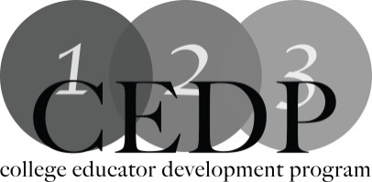

ePortfolios – James Mears

Workshop Description:

An ePortfolio or Digital Portfolio is a collection of artifacts in electronic format for the purpose of demonstrating various proficiencies and showcasing specific accomplishments. This workshop will examine the nature and various uses of ePortfolios as evidence of academic and experiential mastery of competencies within higher education.

Learning Outcomes:

- Participants will be able to identify the value of using ePortfolio to provide stakeholders with a clear, concise view of skill mastery and learning accomplishments.
- Participants will engage in discussion on the use and applicability of ePortfolios in higher education.

Facilitator: James Mears, St. Clair College
For more information: dmears@stclaircollege.ca

Resources:

Herteis, E. M., & Simmons, N. (2010). The portfolio process. Society for Teaching and Learning in Higher Education: The University of Western Ontario.

Kimeldorf, M. (1997). Portfolio power: The new way to showcase all your job skills experiences. Retrieved from http://amby.com/kimeldorf/portfolio/p_mk-03.html

Wright, W. A., Herteis, E. M., & Abernethy, A. (Eds.) (2001). Learning through writing: A compendium of assignments and techniques (Rev. Ed.). Halifax: Dalhousie University.

Zubizarreta, J. (2009). The learning portfolio: Reflective practice for improving student learning, 2nd ed.. San Francisco: Jossey-Bass.

